Meet the integrated farmer and discredit him /be impressed.
I do not know what it is, but when someone proudly shows his successful enterprise to a group, the Pavlov reaction is to try and discredit it. ‘He gets too much money from the EU, his buildings are not environmentally friendly or he uses cheap Hungarian labor and imported coconut soil substrate. ‘ Those were some of the reactions (including myself) from the audience when we visited a tremendously successful tomato and pepper grower near Vienna during the EISA farmer exchange, which was sponsored by SAI Platform.
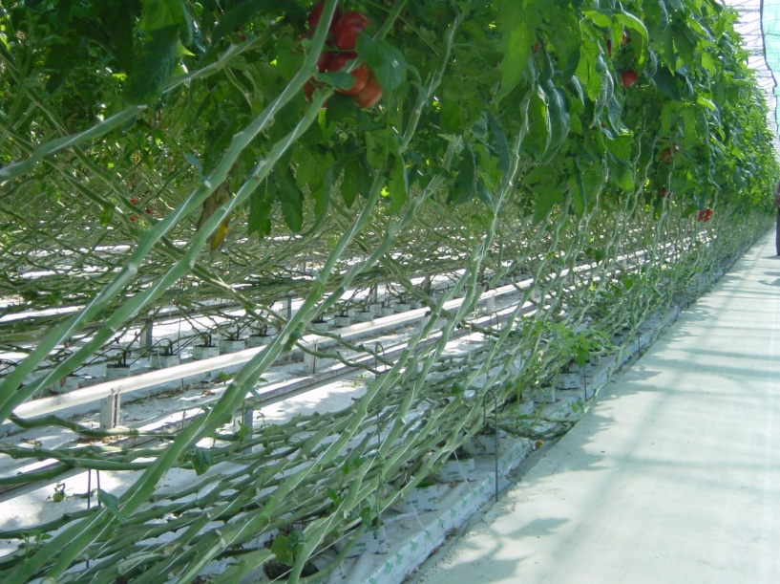
Mr Perlinger grew to a 50 % market share of fresh tomatoes and paprika in Austria in 15 years and is still growing. He set up a collection infrastructure that helped the region to outwrestle economic decline in the nineties with help of EU rural development money. Next to the impressive greenhouse production he leads the collective trading of all fresh produce in the region.
But what is the sustainable or integrated farming part of his work? Is that limited to the fact that he in his glasshouses doesn’t use any pesticides and bumblebees for fertilization? Or is it his economic sustainability? Or the composting of the plants after the season? Or the extremely high yields? Please tell me.
Because we were promised a wine tasting at Austria’s best winery Hans Moser, I only took the importance of cover crops and proper cutting of the leaves as crucial elements of the ‘integrated wine’. And some of the wines were indeed surprisingly good value for money. Hans’s passion for the winemaking impressed me more than his agronomic story. But that’s also a matter of taste. The most important sustainable indication for me that he was doing a great job I learned from the fact that both his son an daughter were studying wine and wanted to follow in his footsteps.

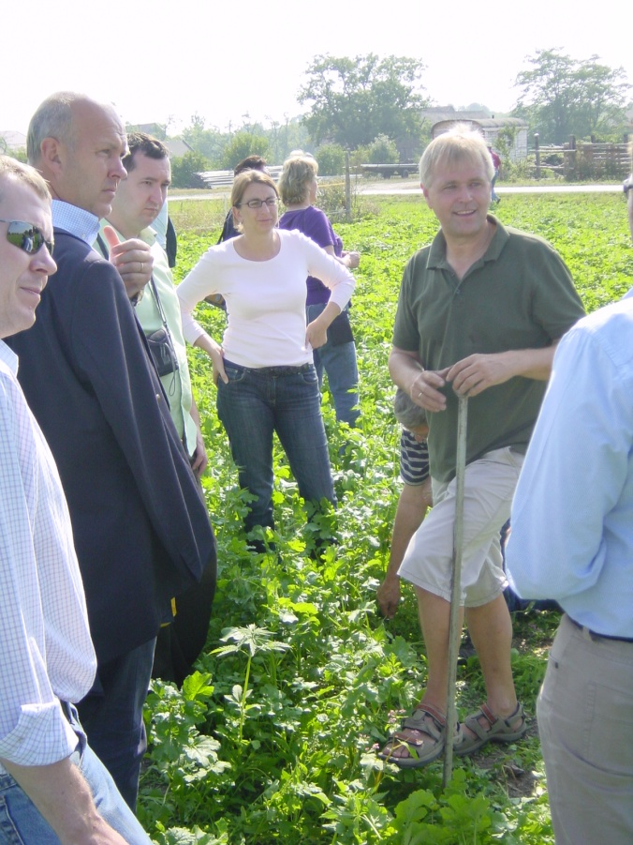
The story of the next, organic, farmer Mr Weiss was also heavily doubted. ‘ It can’t be true that you can irrigate with so little labor, I don’t believe you’, was the reaction of a French colleague farmer. The farmer just smiled and persisted that he did. He openly shared his financial data and that seemed to have some flaws: he didn’t calculate the cost of land (family possession for a longtime) or depreciation of the electric pumps in his field (been paid for years ago). But the farmer continued proudly and kindly smiling that his old parents still daily worked on the farm and that his children were already preparing to take over. And he admitted without shame that he was lucky to have ‘organic subsidy’, a dry wind that removed all fungi (hence no fungicide) and free water from the nearby Danube and a good price for his seeds and products. So the step from integrated farming to organic had only advantages for him.’ I would be stupid if I didn’t’, he told us. We went to his field that had just been sawn with cover crops that were chosen to take nitrogen out of the soil before the winter to prevent it from washing out. If you have any doubts what biodiversity can actually mean, here it was; colorful, butterflies, perfect soil and very diverse. The audience was more and more impressed by his excellent craftsmanship and joy of life. Or was it because the cannabis, being one of the nitrogen fixing crops?
The third day was for the diehards only (7 out of the 40 participants): a visit to a test and research station of the Vienna University on soil erosion by water and the impact of no or low till agriculture (part of the integrated farming concept). Long term results show that reduced tillage and cover crops reduction of erosion and a lesser runoff of nutrients and pesticides. Moreover, the research also showed positive effects the emission of carbon from the reduced tilling fields, less respiration and considerable less fuel for the tractor. Yet a bigger need for herbicides, as a tradeoff…. What is sustainable?
Peter Erik Ywema, Vienna, Sept 23

Choose the appropriate title according to your own impression
We have been given interesting reports and articles. Call me if you want to know more.

